CONTEXT DIAGRAM (DFD LEVEL 0) FOR
ASHISH KUMAR DALAI-23SCSE1012454
SECTION -29

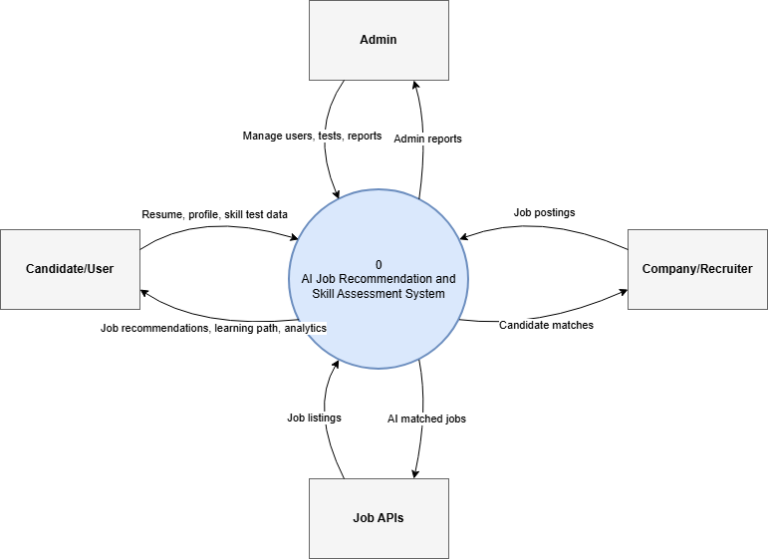
THE AI-DRIVEN JOB RECOMMENDATION AND SKILL ASSESSMENT PLATFORM

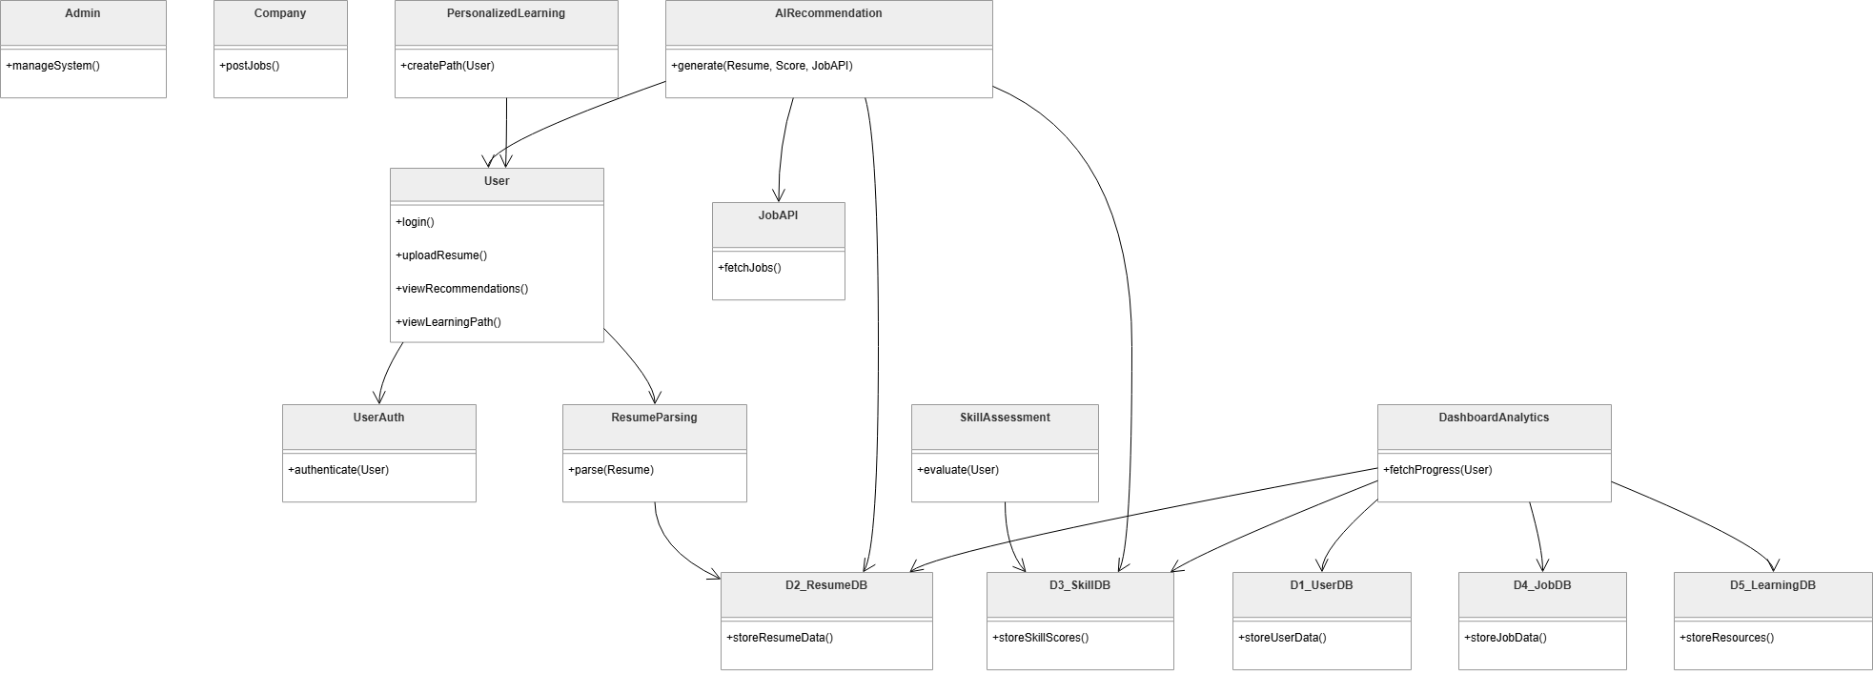
CONTEXT DIAGRAM (DFD LEVEL 1)
CONTEXT DIAGRAM (DFD LEVEL 2)

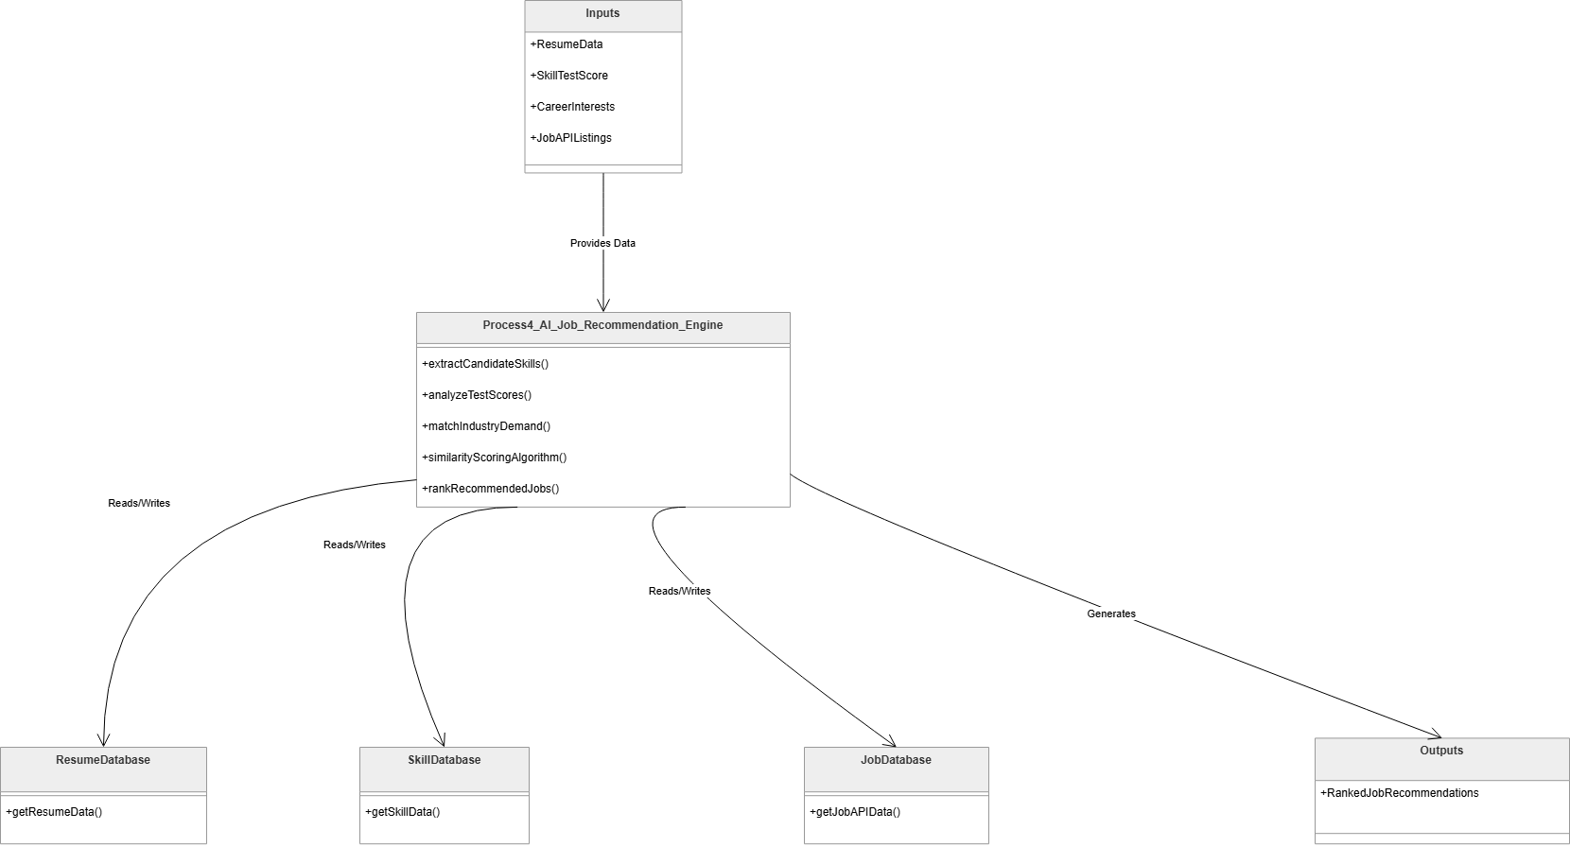

ASHISH KUMAR DALAI-23SCSE1012454
SECTION -29

